For other Data analytics projects, follow this github link - <https://github.com/ManukrishnanBS/Analytics>

SQL for DATA ANALYTICS

Create a query to find the customer from each country that has spent the most money at our store, ordered alphabetically by country. Your query should return the following columns, in order:

* country - The name of each country that we have a customer from.
* customer_name - The first_name and last_name of the customer from that country with the most total purchases, separated by a space, eg Luke Skywalker.
* total_purchased - The total dollar amount that customer has purchased.



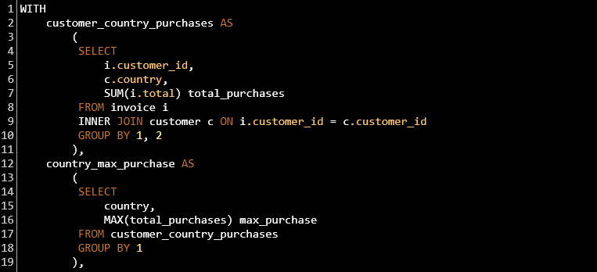

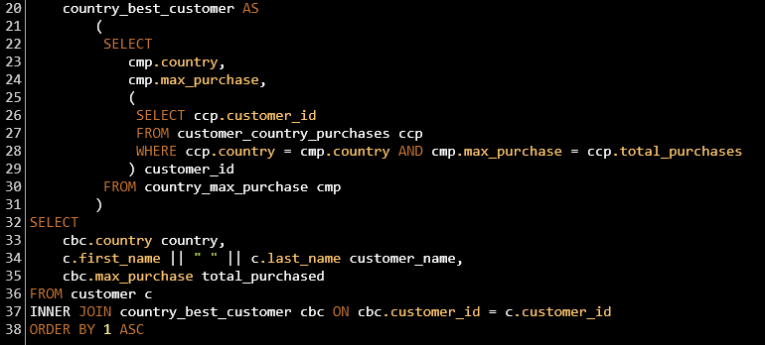

Output

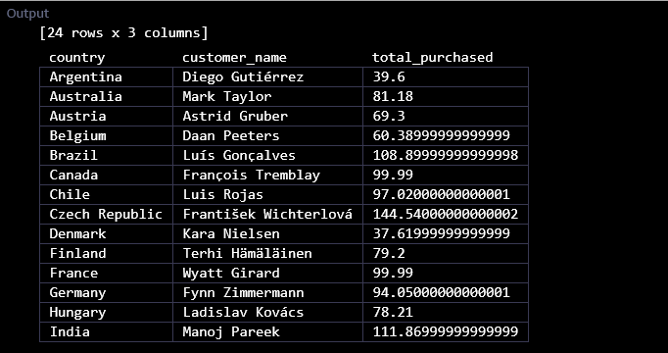

Write a query that returns each genre, with the number of tracks sold in the USA:

* in absolute numbers

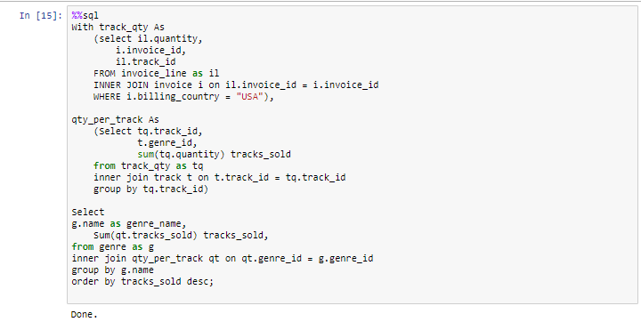

OUTPUT

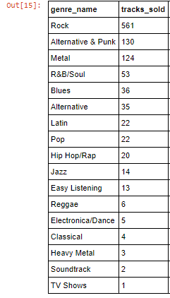

Write a query that collates data on purchases from different countries.

* Where a country has only one customer, collect them into an "Other" group.
* The results should be sorted by the total sales from highest to lowest, with the "Other" group at the very bottom.
* For each country, include:
  + total number of customers
  + total value of sales
  + average value of sales per customer
  + average order value

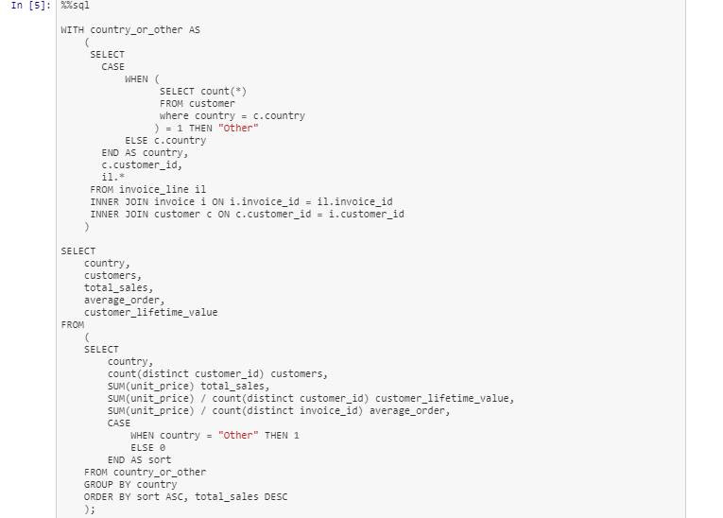

Output

